A STUDY OF TRANSFORMATIONAL LEADERSHIP FRAMEWORK DURING COVID-19 PANDEMIC IN MALAYSIA

^{[1]} Kris Ke Shyang See, ^{[2]}Miccele Lee Ching Siow, ^{[3]}Masinne Ming Fon Yup, ^{[4]}Kenny Kian Boon Tan, ^{[5]}Wen Yang Pang, ^{[6]}Andy Bak Kar Khor
^{[1]} AIMSMET, ^{[2][3[4][5][6]} AIMSMET, Asia Metropolitan University

Abstract: - This study analyses various leadership frameworks, leadership styles of institutions, government and healthcare organizations around the world during COVID-19 pandemic. We attempt to present recommendations and adoption of a transformational leadership framework for COVID-19 pandemic in Malaysia. At the time of writing, Malaysia’s measures appear to be incoherent and COVID-19 infective cases are escalating with majority of livelihoods threatened and communities left in disarray. A framework of good practices for transformational leadership is offered drawn from this study, in the hope transferable lessons can be taken to aid the nation and others in the continuing struggle to limit the harm COVID-19 poses to lives and livelihoods throughout the world.¹ Prior to the outbreak, Malaysia has just experienced a change of government through her 14th General Election.² Nationalism was at an all-time high. However, inheriting policies of the past administration, well-crafted programs of nation building have not been properly implemented. While the government has achieved impressive economic development, it is at the same time becoming more authoritarian and the country faces a range of disturbing social and political problems. Thanks to a growing educated middle class, urbanization, demographic change, globalization, and the spread of the Internet, mass-based civil movements and a multi-ethnic coalition of opposition parties have emerged with the potential of redressing the situation.³ We would attempt to address how transformational leadership will take its role in nation-building. The theory behind transformational leadership is discussed. An explanation of how transformational leadership is practiced is also included. Finally, a discussion of the current state of the health care industry is initiated, with a look at how transformational leadership is the best leadership style to transform the nation through a totality of political, public health and economical as a whole, for the better.⁴

INTRODUCTION

A little more than a decade ago, G-20 leaders gathered in London, along with heads of international bodies like the International Monetary Fund (IMF), to stop a worsening financial crisis turning into a global depression.⁵ Now, facing what Kristalina Georgieva, IMF managing director, describes as a crisis "way worse" than 2008, those same institutions have faltered. And rather than crafting a new global plan, the two global powers best suited to lead a response, the U.S. and China, have sniped at one another from the side lines. On any measure, the global response, on political level, public health and economic policy, has been unacceptably slow and disorganized. While national governments have introduced unprecedented measures to slow the disease and prepare for its economic impact, international action has been held back by squabbling and limited leadership. The COVID-19 pandemic called for coordinated action, however, no one answered.⁶ Without the two global powers, U.S and China to lead a response initially, most countries need to look within themselves to search for answers. While many countries faltered initially, New Zealand emerged as a leader in the Pacific region in successfully combating COVID-19. This early success is a result of timely leadership and is widely termed as “crushing the curve”.⁷ New Zealand’s leadership resulting in early success, has inspired rest of the nations around the region to follow and learn from their measures.
Leadership has become an increasingly important element in the success or failure of nations, business enterprises and organizations, and a scarcer resource, yet our understanding of the competencies of effective leadership remains limited. Leadership, and leadership development, are being transformed by trends that represent both ongoing evolution of global needs and the creativity of responses to them.⁸
The COVID-19 pandemic has emerged as an unprecedented international humanitarian crisis. In times like these, there is volatility, uncertainty, complexity, and ambiguity that need rapid, high-impact decisions in a limited information setting. Leaders have to manage these elements, learn new lessons along the way, and help to develop various creative problem-solving strategies to keep their enterprise operational and communities safe and well cared for.⁹ It has been a year since Malaysia recorded its first coronavirus infection, on 25th January 2020. In response to this, the Malaysian government reviewed the implemented measures i.e. Movement Control Order (MCO) from time to time, based on the current COVID-19 situation in the country. As of 4th February 2021, Malaysia recorded 231,483 total COVID-19 cases, of which 48,771 were hospitalised, 181,886 recovered and 826 deaths. The Malaysian government implemented Movement Control Order (MCO) 2.0 nationwide except Sarawak until 18th February 2021, with relaxation for the micro economy. Except for Sarawak which will continue to be under Conditional Movement Control Order (CMCO). MCO 2.0 aims to stem the spread of the COVID-19 pandemic and the Malaysian Ministry of Health (MOH) projected that MCO 2.0 would effectively reduce daily COVID-19 cases by 80%. Interstate travel still not allowed. With a tightening of the current Standard Operating Procedure (SOPs), most businesses are permitted to operate during MCO 2.0.¹⁰
The concept of transformational leadership was initially introduced by James V. Downton, the first to coin the term "Transformational leadership" in 1973, a concept further developed by James MacGregor Burns in 1978 and later, Bernard M. Bass in 1985.

Problem Statement
Politics
The country’s recent surge in cases is a perfect storm caused by a government without legitimacy, a bureaucratic structure that hampers a whole-of-government approach, and a fetish for fiscal discipline, all at the wrong time. Malaysia’s third wave of infections started in September last year at a detention facility in Sabah, and spread as politicians and political workers travelled to campaign for the state’s elections. Now, with daily case numbers regularly exceeding 4,000 for most past of the past month, with some days even exceeding 5000 cases, it’s clear that the pandemic is out of control. Authorities announced a second lockdown, or movement control order, on January 11 to contain the spread of Covid-19, while the king declared an emergency on January 12 on the advice of politically embattled Prime Minister Muhyiddin Yassin. Malaysian opposition leader Anwar Ibrahim has subsequently filed a lawsuit against Prime Minister Muhyiddin Yassin and the federal government, by initiating a judicial review challenging Mr Muhyiddin's advice to the king to suspend parliamentary sittings during the country's state of emergency.¹¹

Public Health
Since the beginning of the year, five of Muhyiddin’s 32-member cabinet have tested positive for the virus. For months, health workers have urged the government to prioritise limited hospital resources, particularly beds in intensive care units and ventilators, for severe cases. But the Health Ministry has only recently decided to allow those Covid-19 patients who are asymptomatic or show only mild symptoms to quarantine at home – finally falling in line with World Health Organization recommendations. The Health Ministry’s standard procedures often are vague and non-transparent. Due to the recent spike and constrained by limited human resources, it has also practically abandoned contact tracing. Many crucial data is also not shared from the federal government with the state government. Common folks are seeking for leadership in times of great confusion, which is seriously lacking. Malaysia has a two-tier health care system, yet many of the profit-making private hospitals in its big cities are actually owned by sovereign funds or government-linked corporations, and are only dressed up to operate like private entities. There are also ubiquitous private clinics, which offer relatively inexpensive outpatient care, but these have yet to be mobilised for the Covid-19 fight. The country was not as aggressive as some of its neighbours in trying to procure vaccines, dumbfounding observers when it missed an earlier deadline to join the WHO-backed COVAX facility. Science Minister Khairy Jamaluddin, whom at the time of writing was appointed as the “Immunisation Minister”, became more visible in the wake of this slip up and led the catch-up effort, with vaccines reportedly set to start arriving in the country in late February. However, the start-stop negotiation of COVID-19 vaccines has put most of the public questioning if indeed the vaccines would arrive, and if it arrives – the distribution channels.

Economics
Prime Minister Muhyiddin Yassin mentioned that Malaysia’s economy is losing an estimated MYR 2.4 billion daily during the MCO, a total of MYR 63 billion, as all the business activities are suspended. According to the Malaysian Ministry of Finance, Malaysia’s gross domestic product (GDP) is expected to contract by 4.5% in 2020, before regaining its growth in 2021 of 6.5% to 7.5%.¹¹ The implementation and subsequent extension of the Movement Control Order (MCO) have greatly affected Malaysia’s economic performance.

As a whole – Malaysia was hit with a triple whammy – a medical pandemic, an unstable government, and an economic recession. The situation is unlikely to reverse in near future, with Malaysia now ranked 29th country in the world, and 1st in ASEAN with the most number of active infection COVID-19 cases according to according to data from the US-based Johns Hopkins University,¹² we dropped six spots to 57th position among 180 countries in the Transparency International (TI) Corruption Perceptions Index (CPI) for 2020,¹³ we lost foreign direct investment at a worse rate than both its neighbours and the rest of the world during the pandemic-hit 2020, according to the United Nations Conference on Trade and Development’s (UNCTAD) Investment Trends Monitor.¹⁴

Most of these problems could be attributed due to an incoherent and lack of leadership in times of crisis. An need for redefinition and implementation of leadership is urgently required.

Literature Review

We would attempt to review differ leadership frameworks in the past decade.

- NHS Leadership framework

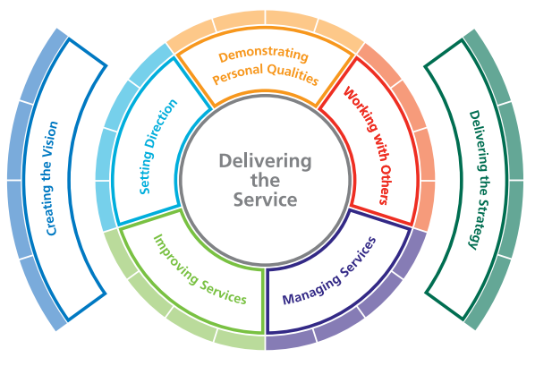
Diagram 1 – NHS Leadership Academy – Leadership framework

The Leadership Framework is created to guide key personnel to comprehend their advancement and development as a leader, aiming to fostering and developing talent. The above diagram illustrates the leadership with delivery of service as the core. This leadership framework applies to all areas of the organisation and to all levels of the organisation. As mentioned by DuBrin that ‘crisis is a low viability, high impact event that threatens the organisation from unknown cause, affect and resolution as well as the belief that decisions must be made quickly.¹⁵ This description has high similarities with the Covid-19 pandemic characteristics.

In the last two pandemics (SARS and H1N1), Malaysia was not affected much and did not feel the full impact of pandemic on healthcare, economic and country. The current Covid-19 pandemic has affected Malaysians not only in terms of health but also our economy and politics. In the past decade (2010-2019), there has not been one infectious disease that has achieved four figures daily new infected cases and with the possibility of death to infected individuals. This proves the highly infectious nature of the virus and calls for prompt response to it by the authorities. Healthcare workers had to adapt to stricter standard-operating-procedures (SOPs) for self-protection against infection and develops means and ways to manage the virus and ensure survivability of the infected. This virus has brought a new environment to the health and medical industry workers and they have to adjust to the new norm soonest for containment of the virus. They have to establish the core objectives and directives clearly to the leaders and for leaders to cascade it down to the teams as per the below illustration.

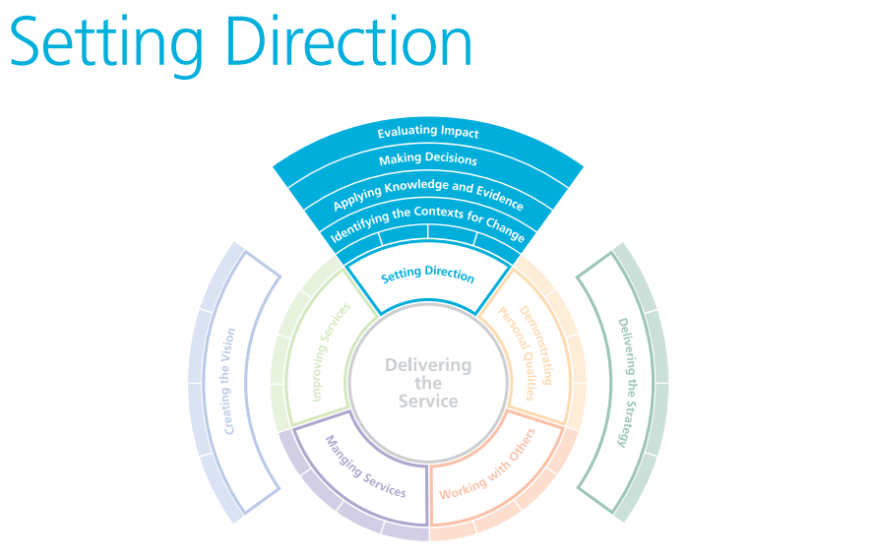
Diagram 2 – Setting direction
To cite an example, during the May 12, 2008, the 5-12 earthquake in China, research was done with data collected from 146 team, 146 leaders and 526 members reflected that during crisis, leaders are expected to react and provide remedial action or solutions. Leaders are expected to lead organisations or people towards a solution, recovery or improvement.

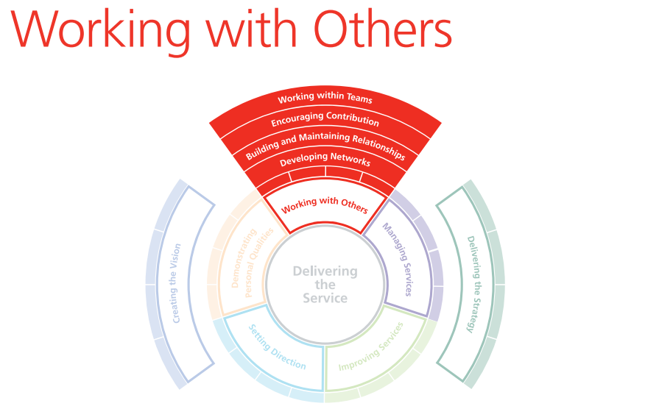Diagram 3 – Working with others
As per Diagram 3, it shows leaders are expected to lead organisations, people and teams towards a solution, recovery or improvement. They are to encourage and inspire members to work collaboratively and express ideas for solutions and management processes.¹⁶ Looking at transformational leadership, it is noted that characteristics include (but not limited to) organisational learning, employee effectiveness, creative flexibility, communication competency, leadership effectiveness and employee satisfaction.¹⁷

- Collective Leadership Framework in Pandemic Influenza Preparedness (PIP)
Prior to COVID-10 pandemic, few events have marked humanity as gravely as the influenza pandemic of 1918. With an estimated 50-100 million deaths, it remains one of the deadliest public health events on record.¹⁸ Our highly interconnected world allows pathogens to spread at lightning speed, increasing the urgency to ensure that all countries are prepared to respond to an infectious disease outbreak wherever it may emerge. The World Health Organization (WHO) works to ensure that all countries, irrespective of their income or development status, have equitable access to the medical and other counter-measures necessary to respond to pandemics.
It is for these reasons that the Pandemic Influenza Preparedness (PIP) Framework was set up in 2011 as a bold and innovative preparedness tool that puts virus sharing and benefit sharing on an equal footing.¹⁹ PIP framework holds such importance for public health: it shows that nations can come together and solve the most difficult issues through innovative solutions; that countries will undertake the work needed to strengthen their preparedness capacities; and that partners – public, private and non-governmental – will sustain their commitment to achieving the highest level of preparedness so that our future global response is founded on solidarity and equity.

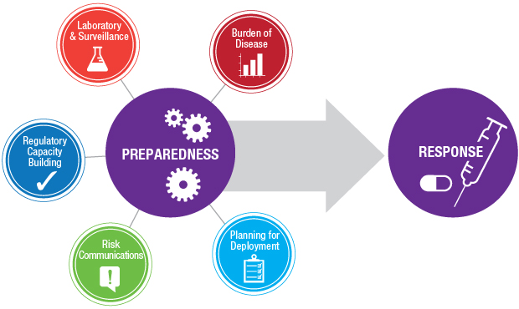
Diagram 4 – PIP Framework

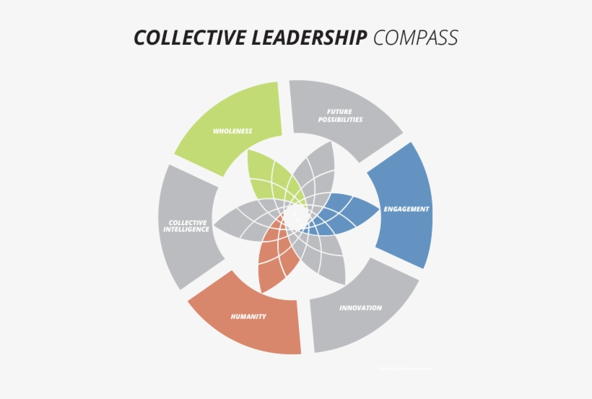
Diagram 5 – Collective Leadership Framework

To date, the dominant approach to leadership research assumes that all aspects of the leadership role within a team are embodied by a single individual. In the real world, however, this is rarely the case. Rather, multiple individuals within the team may serve as leaders in both formal and informal capacities, and the shifting of leadership responsibilities is often rooted in which individual's expertise is most relevant to the given problem.

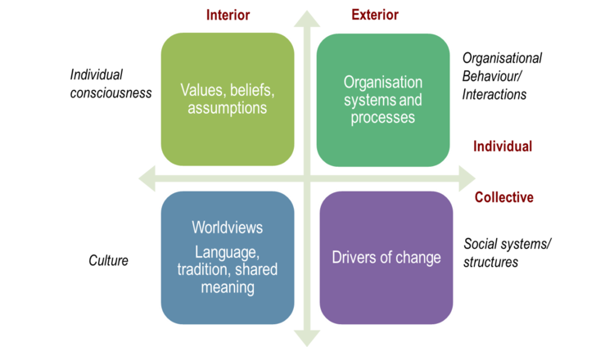
Diagram 6 – Collective Leadership The What, Why and How

Collective leadership describes the processes by which people come together to pursue change. Within these processes, participants jointly envision what the world should be, make sense of their experiences and interactions, and shape their decisions and actions to produce desired results. Leadership processes increase capacities for collaboration and provide conditions for group members to feel valued and motivated in contributing to collective goals. Leadership is thus a collective achievement.²⁰ Throughout the implementation, preparedness capacities improved globally, regionally and in priority countries during the four- year implementation period, from 2014 to 2017. Of the 21 indicators established to monitor progress, targets for 15 (71%) indicators were met or exceeded. Notable advances were made in each area.

As evidenced by the success of PIP framework, harnessing collective leadership, in collaboration and partnership were key to implementation. Funds were used in synergy with other investments from government agencies globally and bilaterally, the private sector, foundations, civil society, and multi-lateral agencies. By working together, partners contributed to improve pandemic preparedness.

- The Duke Healthcare Leadership Model

This leadership model specific to healthcare using concept mapping. The research led to a model based on the core principle of patient centeredness and core competencies of emotional intelligence, integrity, selfless service, critical thinking, and teamwork.

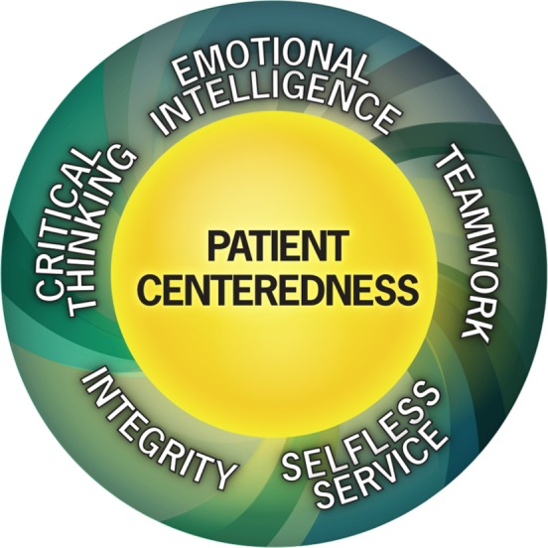
Diagram 7 - The Duke Healthcare Leadership Model

The Duke Healthcare Leadership Model is specific to healthcare using concept mapping. The research led to a model based on the core principle of Patient Centeredness and core competencies of Emotional Intelligence, Integrity, Selfless Service, Critical Thinking, and Teamwork. The researchers have found this model useful for teaching leadership skills, and are currently designing a relevant evaluation instrument.²¹

Transformational Leadership

Leadership is an element that is required in all organisations and operations. Leaderships is subjective but is basically the ability of one person to have Followers. The five types of identified leadership:

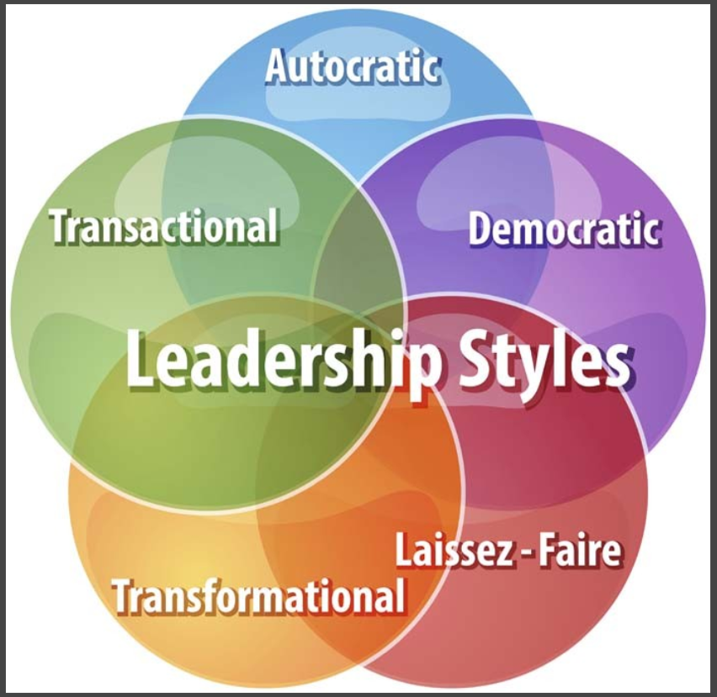
Diagram 8 - Leadership Styles

Considering leadership styles applicable to the health and medical industry especially applicable during the Covid-19 pandemic. From the above diagram, we bring our focus to transformational leadership.²² The term "transformational leadership" was coined by sociologist James V. Downton in 1973. Leadership expert James MacGregor Burns in 1978 defined transformational leaders as those who seek to change existing thoughts, techniques and goals for better results and the greater good. Burns also described transformational leaders as those who focus on the essential needs of the followers. Later, Bernard M. Bass, 1985 further developed Burn’s theory on Leadership by adding a psychological notion to the factor.²³ There are 4 typical characteristics that outline or form the basis of transformational leaders.

- Inspirational Motivation
- Idealized Influence
- Intellectual Stimulation
- Individual Consideration

Transformational leadership can be seen when leaders and followers promote higher morality and motivation. Transformational Leadership Framework regards the behaviour and characteristics of the leader as a transformational force that empowers subordinates and changes the organization. Leaders will be able to instil change because they are outstanding role models.²⁴

As proposed by Bass and Avolio,²⁵ the development of the ‘Four I’s’ as a management strategy that looked at the development of transformational leadership as: Idealised influence, Inspirational motivation, Intellectual stimulation and Individualised consideration. They believe that management should “inspire the innovation and creativity of its followers by questioning assumptions, redefining problems, and responding to old situations in new ways.” Within transformational leadership, followers are “encouraged to try new approaches, and their ideas are not criticised because they differ from the leaders’ ideas”. Through transformational leadership, managers are creating psychologically safe spaces, thereby reducing the "fear of failure."
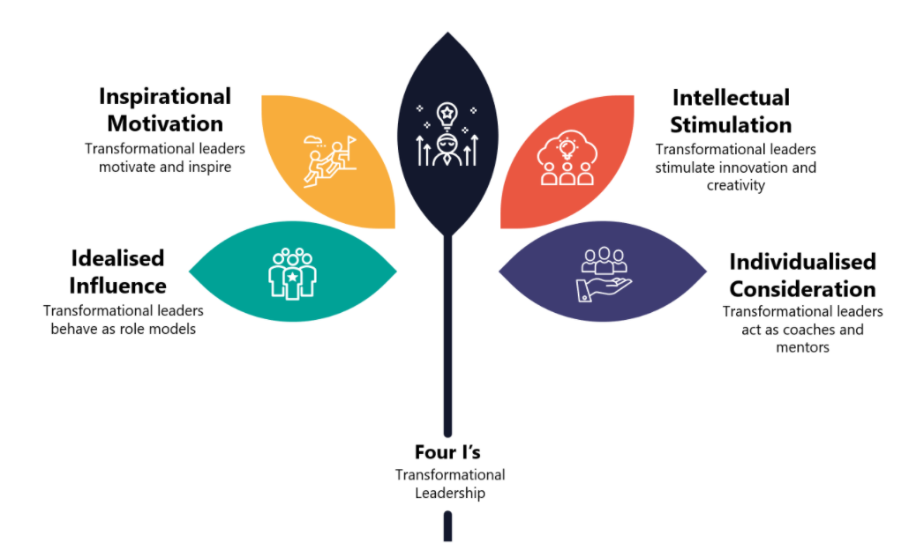
Diagram 9 - Bass and Avolio's Four I's of Transformational Leadership

Recommendations
Our inability to find an appropriate leadership model that could combine all three sectors, politics, public healthcare and economics, led us to ambitiously attempt to create a leadership model specific to our preposition. At the time of writing, Malaysia is experiencing unprecedented challenges on three fronts – politically, public health systems and economics. While this may be the true for many other countries globally, the pandemic has exposed the lack of a leadership in Malaysia. Facing all these uncertainty, the common citizenry’s confidence has shaken. It is imperative that the nation is being put back on the steering wheel in the right direction, failure of which will result in disastrous consequences. We believe by harnessing a systemic transformational leadership framework in accordance to Malaysia’s necessities is crucial to elevate the current state of affairs and will serve as a reference for the future.

Diagram 10 indicates a Proposed Transformational Leadership Framework During COVID-19 in Malaysia and how it can be implemented in Politics, Public Health Systems and Economics.

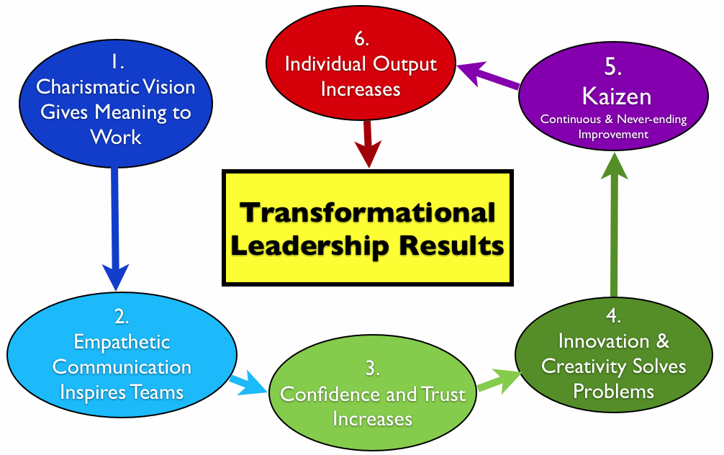
Diagram 10 – Proposed Transformational Leadership Framework During COVID-19 in Malaysia

Politics
The government must take the initiative to engage all different political parties of differ agendas and different ideologies, and actively seek to find common grounds to combat the invisible enemy. This is by no mean, an easy feat, but they must aspire to achieve this and achieve this fast. in times of crisis, focusing on common grounds take higher precedence. As the diagram detailed in Step 1 (Charismatic Vision) and 2 (Empathetic Communication), the government administration must speak with a single voice with a single vision. They must also publicly endorse leaders who have demonstrated good governance and leadership instead of remaining silence. To do so, they must be prepared to “wake up” the office, letting the others who work there know that they must improve or perish. It is a fact that some governmental institutions are slow to recognize the need for this important first step, and are hurt in before they see the need to wake up; Resistance to change needs to be guarded against.

Public Health
More resources have not been utilised in our healthcare systems. Once we set the ball rolling in Step 1 and 2, we must actively promote a Public-Private-People (PPP) collaboration in healthcare systems. Our public hospitals must readily combine their resources with private healthcare organizations, with health ministry taking the lead, mobilising all healthcare personnel and resources from both sides. On-going training and engagement must be initiated from the governing authorities. For this to work – all stakeholders must follow a clear and directed leadership – often from the government. The health ministry must lead without fear or favour, and provide clear picture of the happenings, avoiding pitfalls such as incoherent instructions or vague SOPs, the citizens would then, more likely to go along with it. Clarity would illicit a better response from the communities. This would allow Step 3 to be set in motion (Confidence and Trust increases). Notwithstanding, Step 4 (Innovation and Creativity Solves Problems) will follow suit.

Economics
This is the actual re-working of all the stakeholders involved i.e government sector, community leaders, business leaders, media outlets etc. Step 5 (Kaizen) indicates that our collective communities must remain resilient and be readily adaptive and accepting change. The government, i.e Ministry of Finance (MOF), must work with all stakeholders, both foreign investors and domestic ones and be ready to offer tax rebates, subsidies or emergency fund relief for the needy e.g internationally, the assembly plants setup by foreign director investments (FDI) such as Honda, Toyota assembly plants whose operations could be hampered by the MCO initiated by the government, domestically the B40s, single-parent families. As Malaysia is a multicentric society, the government could also engage all religious groups and seek their help in distributing reliefs to all corners of the nation. Certainly relying on hand-outs is at best, a short term measure, Step 6 (individual output) involves re-training workers and developing new procedures to fit the new paradigm. Government leaders, community leaders, business leaders or even celebrities or influencers could be sought to bring about the message of elevating oneself and one’s abilities, while working towards a common vision that was first set out by the government. A message of individual resilience and reliance will uplift the dull spirit. This is also a crucial stage as being constant responsive to sentiments on the ground would allow minor adjustment to SOPs and protocols. Communication is key to viability for this stage. Firm, persistent and clear instructions would elevate a more positive collective outcome.
The key to these 6 steps of Transformational Leadership Framework is speed. As evidenced by how New Zealand achieve success in deterring COVID-19 infection spread, a large part is due to speed to implement measures. The faster we could mobilise all of our citizenry, our resources, our networks and our collective nationalism, the better we could navigate ourselves out of this pandemic, and emerge stronger and more resolute than before. This is the same nationalism spirit that the country has achieved during independence, and Malaysia rose up to be a powerhouse in ASEAN then. Now, we can do it again.
Conclusion
A key observation from the COVID-19 crisis is how underprepared we are as a country to deal with such a crisis. Building strong relationships with key stakeholders, having a clear understanding of each leader’s role in a future crisis, and developing effective supply chains and other processes are a few examples. Leading during crisis is often stressful and challenging. Transformational leadership is the kind of leadership that makes a nation or organizations grow and thrive because the followers of those organizations are in a supportive environment that encourages them to take initiative and express their individuality, while at the same time providing them with clear objectives to aim for. A nation that is operated with a transformational leadership style is one that is embracing the 21st century; such a country is giving itself every chance of not only succeeding but thriving. This was further expounded by New Zealand Prime Minister Jacinda Ardern, who has been hailed around the world for her government’s quick action on Covid-19, which has helped New Zealand avoid the mass infections and deaths that have devastated world-wide.²⁶

Transformational leaders use compassion and trust to build a sense of community in their organizations or workplaces. This sense of community motivates followers to be their best and to work toward the common good of the country, organization or workplace. With a transformational leader, no longer will followers be self-serving and only putting their most minimal effort out that it will take them to get by. When inspired by a transformational leader, followers come to have a sense of pride and purpose in the organization which employs them, and this breeds loyalty in followers. Loyal followers look out for the best interests of the nation or organization, because they feel connected to it. This kind of loyalty is one of the best investments a nation, business or organization can make in itself.
Transformational leadership is especially needed in the healthcare industry especially during the current pandemic. The people who work in the healthcare industry are suffering from stress and burnout from working almost non-stop since the starting of the pandemic. Transformational leadership would allow doctors, who are the usual leaders in a healthcare environment, to get closer to their staffs and patients on a professional level, which would bring about more openness in the workplace.
In addition to fostering a more open co-operative environment, transformational leadership in the political front, healthcare industry and economical front would lead to a breaking down of the traditional hierarchical system that has kept leaders so removed from their employees. When leaders begin showing their followers individual compassion and concern, and begin celebrating the differences among them, the citizenry satisfaction will rise. This will result in greater loyalty from citizens, which will in turn lead to leaders being able to give their policies executors greater trust and more freedom in taking initiative and risks in their respective sector. This initiative and risk being taken will naturally lead to many improvements in the overall operation of the country. In addition, transformational leaders will be able to communicate a clear picture of the objectives of the nation, which sectors will be happy to follow, as they will be given the room they need to be individuals in the operating of their respective industry. This will lead to not only greater communities satisfaction, but to greater individual satisfaction as well. Transformational leadership, when used in its true form, has the power to transform and enhances nation-building.
Fostering transformational leaderships need to be at institutional, national, regional and international levels. However, key questions to ask ourselves would be: How do we ensure that we maximally prepare for known threats? What are the tools? What are the systems in place? What is the playbook? The answers will be unique for each individual scenario, but the exercise has to be undertaken proactively and the basic principles will be the same as outlined above throughout this study.
There are several limitations to our study. Foremost, model creation is not an exact science. Our mixed methods approach involves subjective interpretation of how the model works. This model is also derived from research done by our individual group, and as a result may not be generalizable to other settings. We do not suggest that ours is the only or best healthcare leadership model. It is offered as a model that others can use and refine for their own environments. The methods we describe can serve as a guide if others desire to create their own institutionally specific model. Nonetheless, this model has guided us towards what we know best for the betterment of Malaysia’s current situation.
Models are most useful when validated. Preliminary validation of our model is complete. Our group is committed to re-validate the model in more diverse and larger population amongst different countries.

References

- Wilson, S., 2020. Pandemic leadership: Lessons from New Zealand’s approach to COVID-19. Leadership, 16(3), pp.279-293
- Nadzri, M. M. N. (2018) ‘The 14th General Election, the Fall of Barisan Nasional, and Political Development in Malaysia, 1957-2018’, Journal of Current Southeast Asian Affairs, 37(3), pp. 139–171. doi: 10.1177/186810341803700307
- Heng, M., 2017. A Study of Nation Building in Malaysia. East Asia, 34(3), pp.217-247
- UKEssays. November 2018. Transformational Leadership: The Best Leadership for Healthcare. [online]. Available from: https://www.ukessays.com/essays/management/transformational-leadership-the-best-leadership-for-healthcare-management-essay.php?vref=1
- IMF. 2010. The Triple Comeback -- the Impact of the Financial Crisis on Global Economic Governance, Speech by By Dominique Strauss-Kahn, Managing Director, International Monetary Fund. [online] Available at: <https://www.imf.org/en/News/Articles/2015/09/28/04/53/sp120810>
- CRABTREE, J., 2021. How coronavirus exposed the collapse of global leadership. [online] Nikkei Asia. Available at: <https://asia.nikkei.com/Spotlight/The-Big-Story/How-coronavirus-exposed-the-collapse-of-global-leadership>
- Who.int. 2020. New Zealand takes early and hard action to tackle COVID-19. [online] Available at: <https://www.who.int/westernpacific/news/feature-stories/detail/new-zealand-takes-early-and-hard-action-to-tackle-covid-19>
- Joel Goldberg, P., 2017. Trends in Leadership and Leadership Development. [online] Graziadio Business Review | Graziadio School of Business and Management | Pepperdine University. Available at: <https://gbr.pepperdine.edu/2017/04/trends-in-leadership-and-leadership-development/>
- Russell Reynolds Associates. 2021. Leadership through Uncertainty | Thought Leadership | Russell Reynolds Associates. [online] Available at: <https://www.russellreynolds.com/insights/thought-leadership/leadership-through-uncertainty> [Accessed 6 February 2021].
- Trade, F., 2021. CORONA VIRUS – The situation in Malaysia | Flanders Trade. [online] Flandersinvestmentandtrade.com. Available at: <https://www.flandersinvestmentandtrade.com/export/nieuws/corona-virus-–-situation-malaysia>
- Yusof, A., 2021. Anwar initiates judicial review over PM Muhyddin's advice to Malaysia king on suspension of parliament. [online] CNA. Available at: <https://www.channelnewsasia.com/news/asia/malaysia-anwar-muhyiddin-parliament-suspension-judicial-review-14044362>
- The Edge Markets. 2020. Economic Report: Malaysia’s economy to grow 6.5% to 7.5% in 2021 after contracting 4.5% in 2020. [online] Available at: <https://www.theedgemarkets.com/article/economic-report-malaysias-economy-grow-65-75-2021-after-contracting-45-2020>
- Othman, A., 2021. Malaysia ranked 29th for number of Covid-19 cases worldwide. [online] The Star Online. Available at: <https://www.thestar.com.my/news/nation/2021/01/28/malaysia-ranked-29th-for-number-of-covid-19-cases-worldwide>
- The Edge Markets. 2021. Malaysia drops six spots to 57th position in Corruption Perceptions Index. [online] Available at: <https://www.theedgemarkets.com/article/malaysia-drops-six-spots-57th-position-corruption-perceptions-index>
- Palansamy, Y., 2021. Malaysia bled FDI at over twice the rate of Asean in 2020, UN agency finds. [online] Malaysia.news.yahoo.com. Available at: <https://malaysia.news.yahoo.com/malaysia-bled-fdi-over-twice-091510094.html>
- DuBrin, A., 2013. Handbook of Research on Crisis Leadership in Organizations. Cheltenham: Edward Elgar Publishing
- Zhe Zhang, Ming Jia & Lihong Gu, 2012.Transformational leadership in crisis situations: evidence from the People's Republic of China, The International Journal of Human Resource
- Cdc.gov. 2018. History of 1918 Flu Pandemic | Pandemic Influenza (Flu) | CDC. [online] Available at: <https://www.cdc.gov/flu/pandemic-resources/1918-commemoration/1918-pandemic-history.htm>
- Pandemic Influenza Preparedness Framework Partnership Contribution High Level Implementation Plan I Final Report 2014-2017. Geneva: World Health Organization; 2018 (WHO/WHE/IHM/PIP/2018.3). Licence: CC BY-NC-SA 3.0 IGO.
- Wagner.nyu.edu. 2021. Collective Leadership | NYU Wagner. [online] Available at: <https://wagner.nyu.edu/leadership/theory/collective>
- Hargett, Charles William et al. “Developing a model for effective leadership in healthcare: a concept mapping approach.” Journal of healthcare leadership vol. 9 69-78. 28 Aug. 2017, doi:10.2147/JHL.S141664
- Chen, Y., Ning, R., Yang, T., Feng, S. and Yang, C., 2018. Is transformational leadership always good for employee task performance? Examining curvilinear and moderated relationships. Frontiers of Business Research in China, 12(1).
- Schneider, G., 2021. WHAT IS YOUR LEADERSHIP STYLE?. [online] PDStrategies. Available at: <https://www.pdstrategies.com/index.php/easyblog/entry/what-is-your-leadership-style>
- White, S., 2018. What is transformational leadership? A model for sparking innovation. [online] CIO. Available at: <https://www.cio.com/article/3257184/what-is-transformational-leadership-a-model-for-motivating-innovation.html>
- Bass, B. and Avolio, B., 2000. Improving organizational effectiveness. Thousand Oaks, Calif: Sage.
- Vox. 2020. New Zealand’s Jacinda Ardern, hailed for Covid-19 response, wins historic reelection. [online] Available at: <https://www.vox.com/2020/10/17/21520584/jacinda-ardern-new-zealand-prime-minister-reelection-covid-19>

