Assessment and Identification of Fungal Diseases of Crops in Shivalic Hills

^{[1]} Manu Vineet Sharma,^{[2]}Hem Chander
^{[1][2]} Department of Biosciences, Career Point University, Hamirpur-176041, Himachal Pradesh, India.

Abstract: - Crop diseases are major threat to farmers. Diseases make the crop plant unhealthy and cause economic losses. Here emerging fungal crop diseases of Shivalic Hills are assessed and identified. Disease incidence and severity methods are used for assessment. In case of identification of fungal pathogens, morphological symptoms of diseased crop plants are quite helpful but not completely effective. So further culture based and microscopic characters of pathogens are observed and considered. Assessment and identification of crop diseases are quite important so that further effective control strategies could develop and crop yield could be enhanced.
Key words—Crop diseases; Shivalic hills; Disease incidence; Disease severity; Fungal pathogen.

INTRODUCTION

Most of the Indian population depends on Agriculture for economy directly or indirectly. India is among top three countries of world for the production of wheat, fruits and vegetable crops. About 58% of people depend on agriculture sector and contributes to 18% GDP of Indian economy [1]. Farmer’s depends on crops for livelihood and also face numerous constrains for quality and yield of crops. Some of constrains are Climatic conditions, ineffective cum traditional farming and crop diseases. Crop diseases could be through imbalance of nutrients, adverse climatic conditions and living organisms. Among living organisms, Fungi contributes to 30% diseases among crops [2]. Diseases have quite negative impact on yield of crops so there is need of effective ways of control strategies for quality yield. For effective control strategies, the assessment and identification of crops diseases is the main criteria. So the main objectives of present study are: 1) To assess the crop diseases by measuring disease incidence and disease severity. 2) To identify the crop pathogen responsible for particular disease.

METHODOLOGY

Study area was district Hamirpur, Himachal Pradesh located in Shivalic Hills North Western Himalayas. Climatic conditions are neutral type, neither extreme hot nor very cold. Annual temperature ranges from 5ºC to 42ºC, Annual precipitation fall is 1572 mm [3]. During 2019-2020, a survey was performed in Hamirpur district for quantitative assessment and identification of crop diseases. The senior and aged farmers of study area were interviewed through already designed questioner. Interviewees were selected on the basis of pilot survey. Affected parts of crop plants were sampled and collected randomly by walking diagonally in the crop field. Quantitative assessment of crop diseases was done by studying the spread of disease in whole life cycle of crop plant. Disease intensity was the proportion of host unit that show symptoms and measured by quadrate sampling method [4]. Disease severity was calculated through keys for assessment of crop diseases. Keys were also produced by observing whole disease cycle of crop plant [5]. Further grades were matched according to the spread of disease on plant part. Disease was identified on the basis of morphological characters on diseases plant parts. Further confirmation was made by isolating crop pathogen on PDA, and observing cultural characteristics [6]. This single criteria was insufficient so further identification was performed by preparing slides and observing them under 40 X and 100 X lens of light microscope [7, 8, 9,10,11,12,13,14,15]

RESULTS

Table 1 Diseased crops showing percentage of disease incidence and disease severity
Sr. No. | Crop Disease | Percentage of Disease Incidence | Percentage of Disease Severity
1 | Leaf Spot of Brassica juncea | 20 | 31
2 | Leaf Spot of Curcuma longa | 70 | 65
3 | False Smut of Oryza sativa | 12 | 21
4 | Red Rot of Saccharum officinarum | 6 | 20

Table 2 Showing crop plant as host, casual organism and family of casual organism
Sr. No. | Host Crop Plant | Family of Host crop Plant | Pathogen | Family of Pathogen
1 | Brassica juncea (L.) Czern & Coss. | Brassicaceae | Alternaria alternata (Fr.) Keissl. | Pleosporaceae
2 | Curcuma longa L. | Zingiberaceae | Colletotrichum capsici (Syd. & P. Syd.) E.J. Butler & Bisby | Glomerellaceae
3 | Oryza sativa L. | Poaceae | Ustilaginoidea virens (Cook) Takah. | Clavicipitaceae
4 | Saccharum officinarum L. | Poaceae | Colletotrichum falcatum Went | Glomerellaceae

Leaf Spot of Brassica juncea:
Initially pale colored spots were observed on Brassica leaf which later on changed in to dark, necrotic spots. Dark grey colored colony was observed on PDA having growth rate 88.23± 0.5 mm at 7th day. Under microscopic observations Dark brown to pale colored conidia were observed on conidiophores. Conidiophores were long and dark pale to brownish in color. Conidia were septate having horizontal to vertical septa, multicellular and moniliform to obpyriform in shape with smooth surface and short beak. The casual organism was Alternaria alternata.

Leaf Spot of Curcuma longa:
Brown colored oblong spots with grayish center were observed on leaf blade. These brown spots were surrounded by pale yellowish color on margin. Later on stages these spots submerged to form irregular shapes on leaf lamina. In sever spread of disease, leaf become dry, dead and fall down from plant. Colony was whitish in initial stages of growth and later on changed to grayish white color. Margin of colony was entire and hyphae were fluffy and irregular. Growth rate was 38.0±0.5 mm in a week. Conidia were spindle shaped having size 29±0.5x4.2±0.5 µm. Conidia were produced from acervuli. Acervuli with setae were also observed. These all characters were of Colletotrichum capsici.

False Smut of Oryza sativa:
Dark greenish colored smut balls were observed from rice inflorescence. Smut balls were orange yellowish when scraped with needle. Whitish colored raised colony with fluffy mycelium was observed at initial stage which later on changed in to yellowish color, having growth rate of 58.94 mm on 14th day of the culture. Hyphae were septate, hyaline having laterally bored conidia. Small, nearly rounde, 10 µm in diameter and olive greenish color chlaymydospores were observed. The pathogen observed was Ustilaginoidea virens.

Red Rot of Saccharum officinarum:
Symptoms of disease develop on both stem and leaves. Rindge of stem become dull in color, when split internally red colored dots like structures with alternate white patches were observed. Mid rib of leaves contain dark red lesions. Earlier these regions on leaf bear acervoli and later on mass of conidia developed which spread in environment to cause infection. Colony was grayish white in color, fluffy hyphae with smooth margin were observed. Growth size was 85.0± 0.5 mm, when observed after a week. Shape of conidia was subulate to orbicular, 5.3±2 x 4.5±2 in size and hyaline in color. The pathogen was Colletotrichum falcatum.
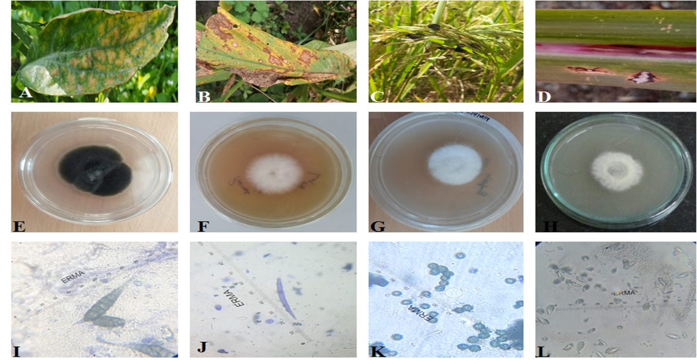
Figure 1: Showing A Leaf Spot of Brassica juncea B Leaf Spot of Curcuma longa C False Smut of Oryza sativa D Red Rot of Saccharum officinarum E Culture of Alternaria alternata F Culture of Colletotrichum capsici G Culture of Ustilaginoidea virens H Culture of Colletotrichum falcatum I Conidia of Alternaria alternata J Conidium of Colletotrichum capsici K Chlaymydospores of Ustilaginoidea virens L Conidia of Colletotrichum falcatum.

DISCUSSION AND CONCLUSIONS:

Crop fungal diseases need much attention in developing countries because these could be the cause of ecological crisis [16]. The current study deals with assessment and identification of crop diseases of Shivalic ranges. Disease incidence and severity of four field crops were estimated. Leaf spot of Curcuma longa was most dominating and red rot of Saccharum officinarum was least in terms of both disease severity and incidence. Among all host crop plant families, Poaceae is most dominant having 2 members, rest are Zingiberaceae and Brassicaceae with 1 member each. Among pathogens Glomerallaceae is most dominant family. It is very important to assess and identify the plant diseases for further calculating the crop loss and crop yields etc. There are further scopes for Economists, Pathologists, Pharma industries and Agriculture etc to move ahead in this area.
Conflict of Interest: All authors declare no conflict of interests in this paper.

REFERENCES:
1.India Brand Equity Foundation, Government of India: Agriculture in India: Information about Indian Agriculture & its importance. Department of Commerce Government of India, 2020. Available from : https://www.ibef.org/about-us.aspx
2.Anderson PK, Cunningham AA, Patel NG, et al. (2004) Emerging infectious diseases of plants: pathogen pollution, climate change and agrotechnology drivers, Trends Ecol.Evol. 19(10):535-544.
3. Chander H, Kumar,G (2020) Some rare Ethno-medicinal plants of lower foot hills of North western Himalaya in Himachal Pradesh. In: Sharma, S.P.A., Sharma,V. Authors, Ethnobotany and Biodiversity Conservation, NewDelhi : Indu Book Services Private Limited,124-143.
4. Brown JF, Keane PJ (1997) Assessment of disease and effects on yield, In: Brown, J. F. & Ogle, H. J. (eds) Plant Pathogens and Plant Diseases. Armidale, Australia: Rockvale Publication, 315-329.
5.Beaumont A (1954) Tomato leaf mould: Spraying trials in Lancashire and Yorkshire, 1949-1952. Plant Pathology 3: 21-35.
6.Smith BJ, Black LL (1990) Morphological, cultural, and pathogenic variation among Colletotrichum species isolated from strawberry. Plant Dis 74(1): 69-76.
7.Than PP, Jeewon R, Hyde KD, et al. (2008) Characterization and pathogenicity of Colletotrichum species associated with anthracnose disease on chilli (Capsicum spp.) in Thailand. Plant Pathol 57: 562-572.
8.Kumar S, Singh V, Garg R (2015) Cultural and Morphological Variability in Colletotrichum capsici Causing Anthracnose Disease. Int J Curr Microbiol Appl Sci 4(2): 243- 250.
9.Rani R, Sharma VK, Lore J, et al. (2015) Cultural studies on Ustilaginoidea virens, the incitant of false smut of rice(Oryza sativa). Indian J. Agric. Sci. 87 (7): 28-31.
10. Wang W-M, Fan J, Jeyakumar JMJ (2018) Rice False smut: An increasing threat to grain yield and quality. Protecting rice grains in post genomic era Edited by Yulin jiaWen-Ming 11.Baithe M (2014) Morphological and molecular characterization of Ustilaginoidea virens isolates causing false smut of rice in India. Indian Phytopathol 67(3): 222-227.
12. Pandey V, Shukla DN (2017). Morphological studies on Red Rot of Sugarcane from Hardoi District of Uttar Pradesh. Int J Agric Innov Res 6(2): 285-288.
13.Viswanathan R, Selvakumar R. (2020) Varietal Breakdown to Red Rot in Sugarcane Revealed by Comparing Two Colletotrichum falcatum Inoculation Methods. Sugar Tech . https://doi.org/10.1007/s12355-020-00855-6
14.Akhtar J, Singh MK (2007) Studies on the variability in Colletotrichum capsici causing chilli anthracnose. Indian Phytopathol 60(1): 63-67.
15.Kumar MS, Devi RSJ, Reddy BVB, et al. (2017) Morphological and cultural characterization of Colletotrichum capsici, incitant of blight of chickpea in Andhra Pradesh, India. Legum. Res 40(3): 592-596.
16.Almeida F, Rodrigues ML, Coelho C (2019) The still underestimated problem of fungal diseases Worldwide. Front Microbiol 10: 214-214.

